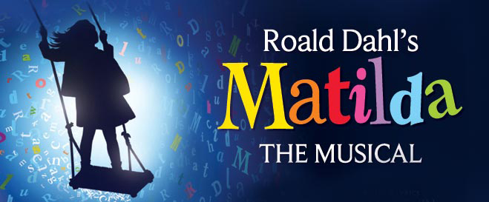

Matilda Cast/Crew

Cast:

Matilda Wormwood-Zaira Felix & Arianna Linares

Miss Jennifer Honey-Leilani Allessi & Lindsay McCormack

Mr. Harry Wormwood-Liam Waelder

Mrs. Wormwood-Erika Relayson

Michael Wormwood-Giovanni Tate

Miss Agatha Trunchbull-Maddie Berkey

Bruce Bogtrotter-Noah Brown

Lavender-Paige Dostal

Nigel- Julious Alfaro

Amanda Thripp-Grace Williams

Miss Phelps- Claire Venisnik

Radolpho-Lincoln Repel

Teacher/Doctor-Hannah Linna

Escapist-TBA

Children’s Entertainer-TBA

Acrobat-TBA

Regnald-John Harrison

Erica-Ryanna Gonzales

Alice- Sierra Rodriquez

Hortensia- Gabby Sewell

Tammi-Trinity Poe

Dancers-
Julious Alfaro
Noah Brown
Sarah Copenharve
Yuma Dennis
Chloe Dostal
Paige Dostal
Ryanna Gonzales
Abigail Harris
Skylar Harris
John Harrison
Hannah Linna
Trinity Poe
Naysa Rangai
Lincoln Repel
Sierra Rodriquez
Leslie Sandoval
Gabby Sewell
Jahnae Stephens
Grace Williams
Megan Weeks

Crew:

Stage Manager: Patricia Sutor
Asst. Stage Manager: Claire Venisnik

Lights:
Landry Paterson-Lead
Gracie Cortez
Leah Verratti

Sound:
Addy Owiny-Lead
Rhae Binoya
Abby Garmer

Props:
Lilly Muetz-Lead
Anna Connolly
Ruby Lester
Marcel Hill

Costumes:
Clara Hooker-Lead
Hailey Albarran
Makeup:
Kaitlyn McCaughey-Lead
Kylie Clarke
Sreeja Muthukannan
Elizabeth Serdar
Scarlette McCann

